**Ideation Phase**

**Define the Problem Statements**

|  |  |
| --- | --- |
| Date | **27 June 2025** |
| Team ID | **LTVIP2025TMID60609** |
| Project Name | **DocSpot: Seamless Appointment Booking for Health.** |
| Maximum Marks | 2 Marks |

**Customer Problem Statement Template:**

Create a problem statement to understand your customer's point of view. The Customer Problem Statement template helps you focus on what matters to create experiences people will love.

A well-articulated customer problem statement allows you and your team to find the ideal solution for the challenges your customers face. Throughout the process, you’ll also be able to empathize with your customers, which helps you better understand how they perceive your product or service.

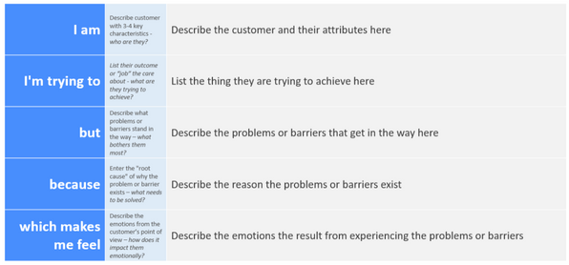

Reference: <https://miro.com/templates/customer-problem-statement/>

**Example:**

**I am I’m trying to But Because Which makes me feel**

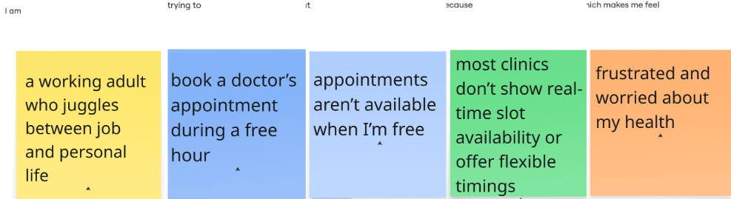

|  |  |  |  |  |  |
| --- | --- | --- | --- | --- | --- |
| **Problem Statement (PS)** | **I am (Customer)** | **I’m trying to** | **But** | **Because** | **Which makes me feel** |
| PS-1 | a working adult who juggles between job and personal life | book a doctor’s appointment during a free hour | appointments aren’t available when I’m free | most clinics don’t show real-time slot availability or offer flexible timings | frustrated and worried about my health |
| PS-2 | a college student new to the city and unfamiliar with nearby clinics | find a verified doctor nearby and book easily | I can’t figure out which doctor is trustworthy and available | there’s no centralized app for instant booking with reviews and ratings | anxious and overwhelmed by too many options |